**Problem Statement:**

Although EV registrations have steadily increased in Germany, there remain regional disparities in adoption and infrastructure readiness. Understanding where adoption lags—and why—can reveal strategic product or service opportunities.

So, to figure out the gaps, we first need to understand what exactly is the statement trying to say?

1. EV registrations are slowly increasing. {Need to verify/validate that}
2. Target Users & Pain Points
3. Gaps that exist in the German market
4. Then we need to figure out state wise distribution within Germany.
   1. Heatmaps within Germany of EV usage
   2. EV registration + Sales within the Bundesland
   3. Charging points and stations (in a plot graph) + Bar charts to show the number of charging stations within metro cities (>1mn people), large cities (>= 1mn > X >=100k), rural side (<100K)

## Analysis

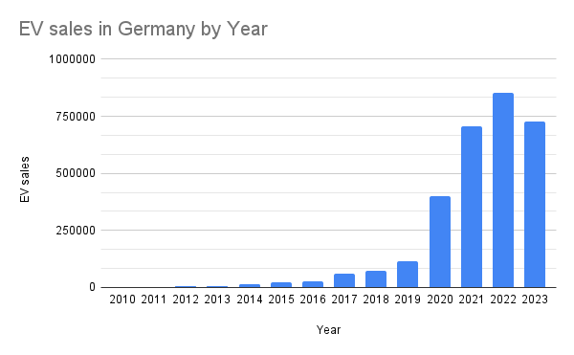**Point 1** 🡪 checks out. It shows the steady and then a sharp rise in increase from 2020 (Covid year) till now. Although there is a blip in 2023, it is yet to be seen what happens in the future.

Data from: IEA. (2024). Global EV Sales: 2010-2024 [Data set]. Kaggle. https://doi.org/10.34740/KAGGLE/DSV/8991634

Bottom Line: There is a steady increase of Electric Vehicles in Germany.

**Point 2 🡪** lets figure out the target users and pain points by imagining two personas.

* Thomas (45), lives in rural Brandenburg, owns a hybrid but finds public charging unreliable.
* Leyla (28), Berlin-based EV user with no home charging point and high usage need.

**👤 Persona 1: Thomas, 45, Brandenburg (rural)**

Problem: There are too few public charging stations near his home.

**JTBD Example:**

*When I plan weekend family trips, I want to be sure there are reliable charging options en route, so I can avoid getting stranded and ensure a smooth drive.*

* **Functional need**: Real-time, local charger availability
* **Emotional need**: Peace of mind, no stress about range
* **Social need**: Feels responsible providing safe transport for family

**👤 Persona 2: Leyla, 28, Berlin (urban)**

Problem: No personal parking or home charger

**JTBD Example:**

*When I finish work late, I want to find a nearby charger that's available, so I can power my car overnight without walking 2 km.*

* **Functional**: Fast availability check
* **Emotional**: Avoid frustration/tiredness
* **Social**: Keep up with eco-conscious lifestyle in the city

**Point 3. 🡪** Market & Competitive Context

* What products or services already exist in Germany?
* How are companies like **Ionity, EnBW, Tesla, Fastned** serving the space?
* Are there digital platforms mapping charging stations or helping in discovery?

As of 1st May 2025, below is the charging facilities available in Germany.

Using the data from “Charging_Infrastructure.xlsx” which is from “Ladeinfrastruktur (LIS) in Zahlen - Inhaltsverzeichnis”.

Assumption: Fast and Normal charges are summed up and not differentiated.